Below is how the GPT/LLM architecture maps to a real production system like ChatGPT — from user request to response, including all the hidden layers (retrieval, safety, orchestration, infra).

🧠 1. End-to-End Production Architecture
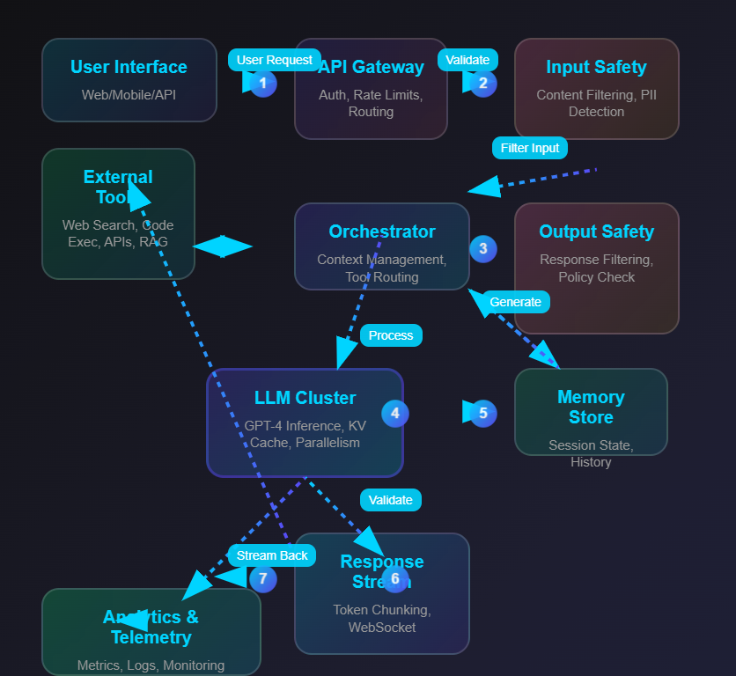
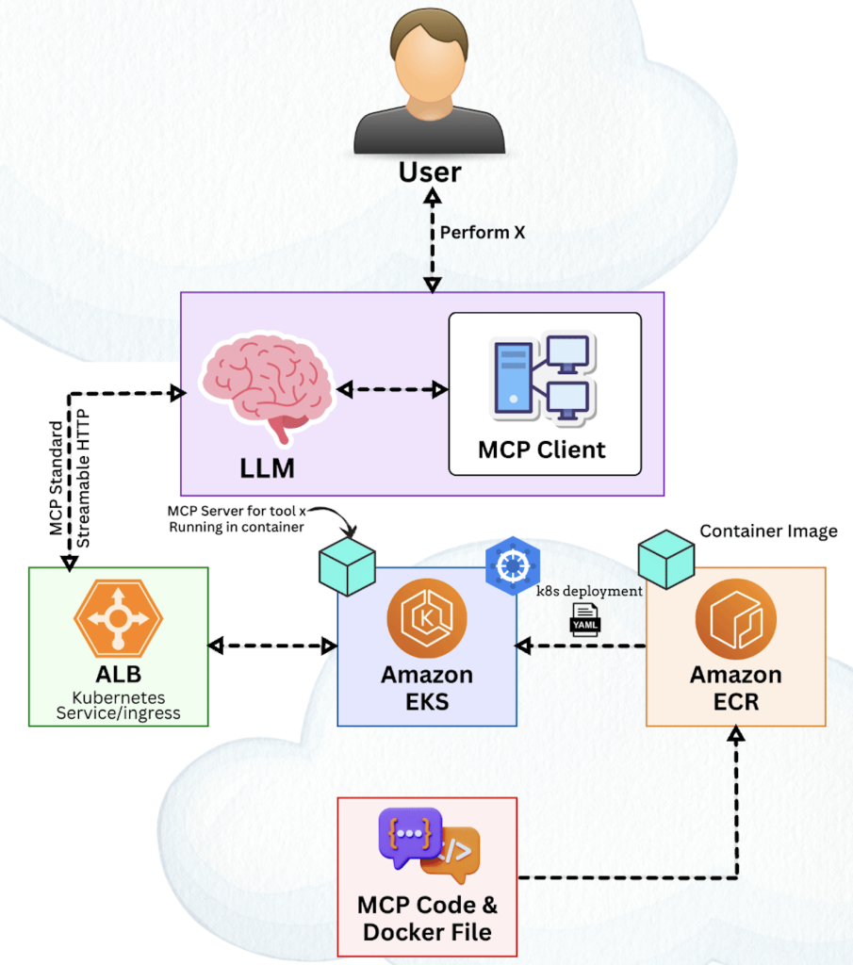
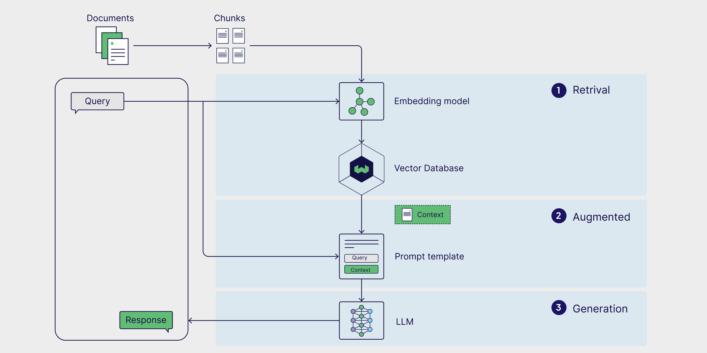
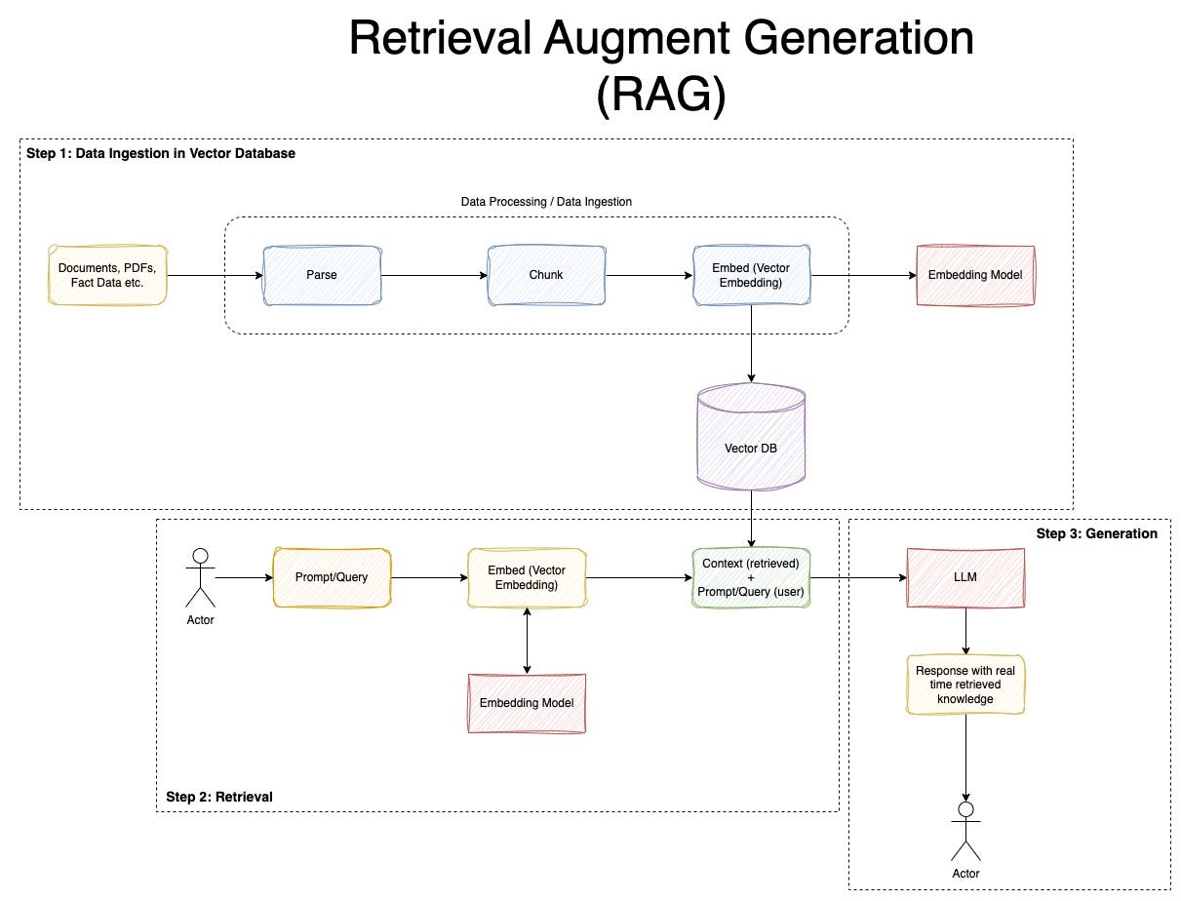
User → Frontend → API Gateway → Orchestrator → (RAG / Tools / Memory) → LLM Inference → Safety → Response

🧩 2. Layer-by-Layer Breakdown

🔹 1. Client Layer (UI / App)
- Web / Mobile UI
- Input box, chat history, streaming output
👉 Example:
- Chat UI similar to ChatGPT web/app

🔹 2. API Gateway
- Entry point for all requests
- Handles:
  - authentication
  - rate limiting
  - routing

🔹 3. Orchestration Layer (Brain Outside the Model)
This is NOT the LLM — but critical.

Responsibilities:
- Prompt construction
- Context assembly
- Tool selection
- Routing logic
👉 Think:
"Should I call DB? Use RAG? Just answer?"

🔹 4. Context & Memory Layer

Types:

🧠 Short-term memory
- Current conversation
- Token window (e.g., 128K tokens)

🗂️ Long-term memory
- Stored user data (optional/personalized)

🔹 5. RAG (Retrieval-Augmented Generation)

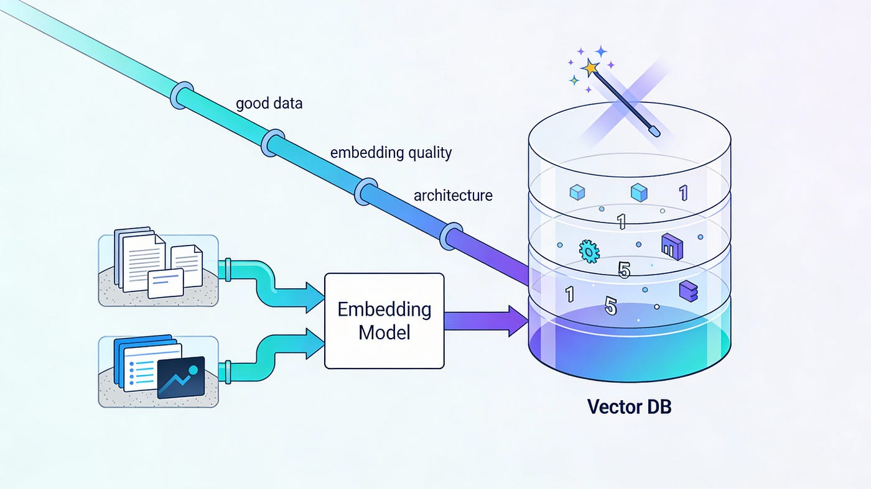

When needed:
Query → Embedding → Vector DB → Relevant docs → Inject into prompt

Components:
- Embedding model
- Vector DB (FAISS, Pinecone, etc.)
- Chunking pipeline

🔹 6. Tool / Function Calling Layer
LLM can call:
- APIs
- Databases
- Code execution
- External systems
👉 Example:
"call_weather_api(city='Mumbai')"

🔹 7. LLM Inference Layer (Core Engine)
This is where actual GPT runs

Internally:
- Tokenization
- Transformer forward pass
- Autoregressive generation

Infrastructure:
- GPU clusters
- KV cache for speed
- Batch inference

🔹 8. Safety & Moderation Layer
Ensures:
- No harmful output
- Policy compliance

Includes:
- Input filtering
- Output filtering
- Policy models

🔹 9. Post-Processing Layer
- Format response
- Add citations (if needed)
- Convert to UI-friendly format

🔹 10. Streaming Layer
Instead of waiting:
Token → Token → Token → UI
👉 Real-time typing effect

🔄 3. Full Request Lifecycle (Step-by-Step)
Let’s trace a real request:

🟢 Step 1: User Input
"Explain AI in simple terms"

🟡 Step 2: Orchestrator
- Builds prompt:
System + History + User Input

🔵 Step 3: (Optional) RAG
- Fetch relevant docs if needed

🔴 Step 4: LLM Inference
- Runs:
  - Step-by-step architecture
  - Inference loop (token generation)

🟣 Step 5: Safety Filter
- Validate output

⚪ Step 6: Streaming Response
- Tokens sent back live

🧠 4. Where Your Earlier Concepts Fit
Concept You Learned | Where It Fits
Step-by-Step Architecture | Inside LLM Inference
Inference Flow | Token generation loop
Training Architecture | Offline (before deployment)
RAG | Context layer
Agents | Orchestration layer

🏗️ 5. Real System Architecture (Engineering View)
Think like your background:

Microservices View
Frontend Service
↓
API Gateway
↓
Orchestrator Service
├── Memory Service
├── RAG Service
├── Tool Service
↓
Inference Service (GPU cluster)
↓
Safety Service
↓
Response Service

Infra View
- Kubernetes cluster
- GPU nodes (A100/H100)
- Redis (cache)
- Vector DB
- Object storage (training + logs)

⚡ 6. Key Production Challenges

🔹 Latency
- Solved via:
  - KV cache
  - batching
  - optimized kernels

🔹 Cost
- GPUs are expensive
- Requires:
  - request batching
  - model optimization

🔹 Scaling
- Millions of users
- Needs:
  - load balancing
  - autoscaling

🔹 Reliability
- Retry logic
- Fallback models

🔥 Final Mental Model
ChatGPT = LLM (brain)
+ Orchestrator (decision maker)
+ RAG (knowledge fetcher)
+ Tools (action layer)
+ Safety (guardrails)
+ Infra (scaling engine)

🚀 One-Line Summary
ChatGPT is not just a model — it’s a distributed AI system where the LLM is only one component inside a larger orchestration architecture

🚀 If you want next (highly valuable for you)
Given your architect + entrepreneur goals, I can:
- Design a ChatGPT-like system for your ₹25–50 Cr startup
- Give team structure (AI, infra, product)
- Show cost vs scale breakdown (India-specific)
- Map to Azure / AWS / on-prem GPU cluster
Just tell me 👍

